Cryptography
Cryptography vs. Cryptanalysis vs. Cryptology
- Cryptography: The science of securing data (making the codes).
- Cryptanalysis: The science of breaking ciphertext (finding the keys or original data without authorization).
- Cryptology: The comprehensive study that encompasses both cryptography and cryptanalysis
Cryptography goals
- Integrity: Ensures that information has not been altered in any unauthorized ways by any means.
- Confidentiality: Ensures only authorized users can access sensitive and protected data.
- Authentication: Verifying the identity of the sender or receiver
- Non-repudiation: ensuring a party in a transaction or communication cannot deny the validity of their signature or the sending of a message.
Basic Cryptographic Terms
- Plaintext: The original, readable message or data
- Cipher: Algorithm used for encryption/decryption.
- Encryption: The process of transforming information into an unintelligible format using an algorithm and key.
- Ciphertext: Encrypted unreadable output..
- Decryption: The process of retrieving the original plaintext from the ciphertext using the key and decryption algorithm.
- Key: Sequence of characters consisting of numeric, alpha-numeric and optionally special characters, used to encrypt/decrypt a message.
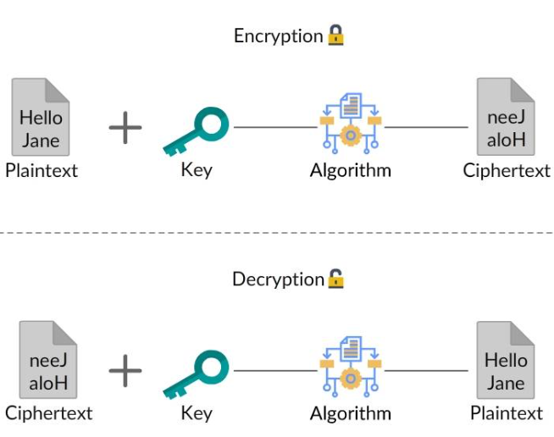
Kerckhoff’s Principle: Security should depend only on secrecy of key—not secrecy of algorithm. Meaning: Attacker may know:
- algorithm
- design
- implementation
Must NOT know secret key
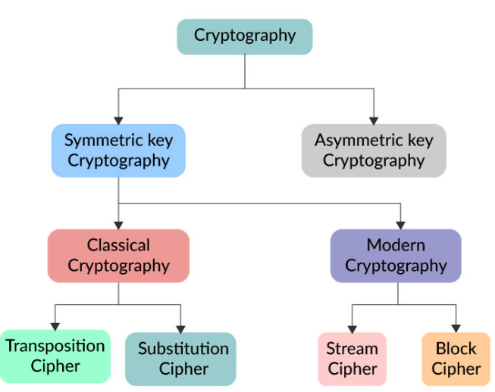

Classical Encryption Techniques
Before computer systems , no digital keys based on
- Transpositional cipher: rearranging the positions of the plaintext letters
- Substitution Cipher: Replace text with other text based on system
  - Cesar cypher: Shift letters CAT e.g. shift 3 becomes FDW
  - Vigenère Cipher: shifts letters using a keyword, changing the shift amount for each letter CAT + KEY
    - C (2) + K (10) = 12 (M)
    - A (0) + E (4) = 4 (E)
    - T (19) + Y (24) = 43%26 = 17(R)
Result MER
  - Beaufort Cipher
    - K (10) - C (2) = 8 (I)
    - E (4) - A (0) = 4 (E)
    - Y (24) - T (19) = 5 (F)
Decryption
    - K (10) - I (8) = 2 (C)
    - E (4) - E (4) = 0 (A)
    - Y (24) - F (5) = 19 (T)

These encryption are weak due to small key space (combination) and due to techniques like frequency analysis certain letters (e.g., 'E', 'T', 'A' in English) occur with varying frequencies. ‘E’ and ‘T’ have highest used frequency while while 'Z', 'Q', 'X', are rare.
Enigma Machine A famous German rotor machine used in WWII. It used multiple rotors, a plugboard and a reflector to create a virtually unbreakable code at the time. The configuration changed with every keypress.

Hashing
- What is Hashing: A process of transforming data (plain text) into a unique fixed-length identifier using an algorithm. It is used to quickly find data in a hash table or to verify data integrity.
- Message Digest: The unique, fixed-size output string generated from an input message by a hash function. Also known as a checksum or hash value.
- Fixed-length Output: Regardless of input size (1 byte or 1 TB), the hash function produces an output of a constant length.
- Deterministic Nature: The same input will always produce the exact same hash output, which allows for consistent verification.
- One-way Property: Hashing is designed to be impossible to reverse. You cannot transform the message digest back into the original plaintext.
- Avalanche Effect: A small change in the input (e.g., flipping a single bit) results in a drastically different output hash, ensuring that even minor tampering is detected
Hash Algorithms
- MD5 (Message Digest 5): Produces a 128-bit hash. Once popular, it is now considered cryptographically broken because it is not collision resistant.
- SHA Family (Secure Hash Algorithm): Developed by the NSA to be more secure than MD5.
  - SHA-1: 160-bit hash, also largely deprecated due to collision risks.
  - SHA-2 (SHA-256/512): Current industry standard, offering strong resistance to collisions and preimages.
  - SHA-3: The latest standard, utilizing a different structure (Keccak) to provide better security

Modern Cryptography
Shannon’s Confusion Principle : obscure the relationship between the key and the plaintext on one hand, and the ciphertext on the other
Shannon’s Diffusion Principle: a single bit of the plaintext, then about half of the bits in the ciphertext should change
Block Cipher: A Block Cipher encrypts plaintext in fixed-size blocks rather than processing data one byte/bit at a time.
- Message: HELLOWORLD
- Split into 5-byte blocks: HELLO | WORLD
- Encrypt: X8@Q1 | Z7#M2
- Output: X8@Q1Z7#M2
Fixed blocks make:
- algorithm design easier
- implementation efficient
- hardware acceleration possible
Common Block Cipher Algorithms
- DES (Data Encryption Standard): An older 64-bit block cipher. It is now considered insecure because its 56-bit key is too easy to crack with modern hardware.
- Triple DES (3DES): A "patch" for DES that applies the algorithm three times to each block. While more secure than DES, it is much slower than AES and is being phased out.
- AES (Advanced Encryption Standard): The global standard. It’s incredibly fast and secure, typically using block sizes of 128 bits and key lengths of 128, 192, or 256 bits.
Rijndael is the algorithm, and AES is the standard. In the late 90s, NIST (National Institute of Standards and Technology) held a global competition to find a replacement for the aging DES. Cryptographers from all over the world submitted designs. Two Belgian cryptographers, Joan Daemen and Vincent Rijmen, submitted Rijndael.
It won because it was:
- Fast: Extremely efficient in both hardware and software.
- Secure: Highly resistant to all known cryptanalytic attacks at the time.
- Versatile: It could run on everything from smart cards to high-end servers.
The One Major Change: When NIST officially adopted Rijndael as AES in 2001, they made a small but important restriction.
The original Rijndael algorithm was very flexible—it could handle block sizes and key sizes in any 32-bit increment (128, 160, 192, 224, or 256 bits). To make the standard easier for developers to implement and ensure universal compatibility, NIST "locked" the parameters:
Often see AES used in things like:
- TLS/SSL: Securing the connection between your browser and a website.
- Database Encryption: Protecting sensitive user data "at rest."
- File Encryption: Securing ZIP files or disk drives (like BitLocker).
Use case
- Full Disk & File Encryption
- Database Encryption
- Secure Web Browsing (HTTPS)
- Cloud & Network Storage
Stream ciphers are symmetric-key encryption algorithms that encrypt plaintext digits (typically bits or bytes) one at a time. Generally faster than block ciphers, making them ideal for high-speed, low-latency scenarios.
- ChaCha20: A widely used modern, secure stream cipher.
- RC4 (Rivest Cipher 4): Once popular but now considered vulnerable.
- Salsa20: A high-performance stream cipher.
- Trivium & Grain: Designed for hardware-constrained environments
Use case
- Real-Time Data Streaming
- Wireless Communications (Wi-Fi/Cellular)
- Internet of Things (IoT) & Smart Devices
If stream ciphers are fast, why not use everywhere? Because it will not be safe for storage at rest.

Asymmetric encryption
In asymmetric cryptography (like RSA), the keys are mathematically linked in such a way that:
- What Key A locks, only Key B can unlock.
- What Key B locks, only Key A can unlock.
Which one you use depends entirely on what you are trying to achieve:
1. Public -> Private (Encryption)
- Action: You encrypt data with the Public Key.
- Result: Only the holder of the Private Key can decrypt it.
- Purpose: Confidentiality. This ensures that even if someone steals the data, they can't read it because they don't have the private "matching" key.
2. Private ->Public (Signing)
- Action: You encrypt data (usually a hash) with the Private Key.
- Result: Anyone with the Public Key can decrypt it.
- Purpose: Authentication. Since anyone can decrypt it, the data isn't a "secret." However, because the Public Key worked, it proves that the person who owns the Private Key is the one who "locked" it. This is the foundation of a Digital Signature.

RSA (Rivest-Shamir-Adleman)
Diffie-Hellman (DH) Key Exchange: A method for two parties to securely exchange cryptographic keys over an insecure channel, often used to establish session keys for symmetric encryption.
DSA (Digital Signature Algorithm): Standard for digital signatures, ensuring the authenticity and integrity of data.
If asymmetric encryption is more secure why not use everywhere. Reason
Computational Overhead
- High Resource
- Larger Time
- Data getting bloated
Modern digital security relies on a hybrid system. Asymmetric cryptography is used briefly to establish identity and safely share a key, while symmetric cryptography does the heavy lifting of encrypting all actual data.
It is the foundation of every HTTPS
- Client: The browser sends its supported cryptographic versions and a random number to the server.
- Server Hello & Certificate: The server sends its Digital Certificate (containing its Public Key) to prove its identity.
- Verification: The browser checks with a Certificate Authority (CA) e.g. DigiCert , comodo to ensure the certificate is valid and belongs to the server.
- Key Exchange: The browser generates a random Secret, encrypts it with the Server's Public Key, and sends it back.
- Session Key Creation: Both sides use the secret to calculate the same Symmetric Session Key (e.g., an AES key).
- Secure Communication: Both sides switch to symmetric encryption. All further data is encrypted using the fast Session Key, which is destroyed after the session ends.
This is not Diffie-Hellman (DH) Key Exchange but similar concept

Digital Signature
A digital signature provides three critical security guarantees
- Authentication: Confirms the identity of the person signing.
- Integrity: Ensures the message was not altered in transit. If even one-bit changes, the signature becomes invalid.
- Non-repudiation: The signer cannot later deny sending the message because only they possess the private key used to create it.
Use case
- Electronic Document Signing: Used to sign PDFs, contracts, and agreements to ensure the document has not been altered after signing.
- Government & Compliance Filings: E-Procurement & Tenders: High-level Class 3 digital signatures are required for bidding in government and private e-auctions.
- Banking & Financial Transactions: Securing online bank transactions, net banking, and authenticating high-value transfers.
- Software Distribution: Developers use digital signatures to ensure that software has not been tampered with or corrupted after publishing.
Here are the simple steps for both the sender and the receiver:

- Trust Setup The Sender gets a Digital Certificate from a Certificate Authority (CA) that contains their Public Key.
  - The Recipient obtains this certificate (either from a public directory or the sender)
  - Verifies it using the CA’s Public Key already stored in their system. Now the recipient has a Trusted Public Key.
- Sender’s Action:
  - Sender hashes the document
  - Encrypts hash with Private Key
  - Sends Document + Signature.
- Recipient’s Action:
  - Recipient takes the Document
  - Creates their own hash.
  - Recipient takes the Signature
  - Decrypts it with the Sender's Trusted Public Key.
- The Check If the two hashes match, the recipient knows:
  - Authenticity: Only the sender has that private key.
  - Integrity: The message hasn't been changed.
  - Non-repudiation: The sender cannot deny sending it.

Authentication

IAM
IAM = Identity and Access Management is a framework of policies and technologies used to ensure that the right people (or software services) have the appropriate access to technology resources.
Identity Represents who a user or system is. Examples:
- Human user
- Mobile app
- Backend service
- IoT device
- Real-world analogy:
- Aadhaar card
- EPIC number voter I card
- Employee ID card
Identification: Track every change to an actor responsible to ensure accountability
- Unique Username/Email ID
- Process ID
- Smart Card
- Biometric Scan, etc
- Service account
- Channel
Authentication is the process of verifying the identity of a user. Identification involves allocating an identity, whereas authentication refers to the checks involved in proving the validity of an identity. Authentication types
- stateful (i.e. session using a cookie)
- stateless (i.e. token using JWT / OAuth / other)

Authorization: Determining what an authenticated user is allowed to do. Examples:
- Read files
- Delete users
- Access admin panel
- Download reports
authentication: verifying identity (401 Unauthorized)
authorization: verifying permissions (403 Forbidden)

Principal: An entity that has been authenticated and allowed to performing actions
- User
- Computer
- Printer
- Application
- Service

Identity | Principal
public class Identity {  private Long id;  private String username;  private String email;  private String firstName;  private String lastName;  } | public class Principal {  private Identity user;  private Set<String> roles; // e.g., ["ROLE_USER", "ROLE_ADMIN"]  private Set<String> permissions; // e.g., ["READ_PRIVILEGES", "WRITE_PRIVILEGES"]  private String sessionId;  private boolean isAuthenticated;  }

Session based Login
- Client POST request
- Server send request in header HttpOnly cookie, Client can’t read
- Gets send automatically in next request
- Server responds
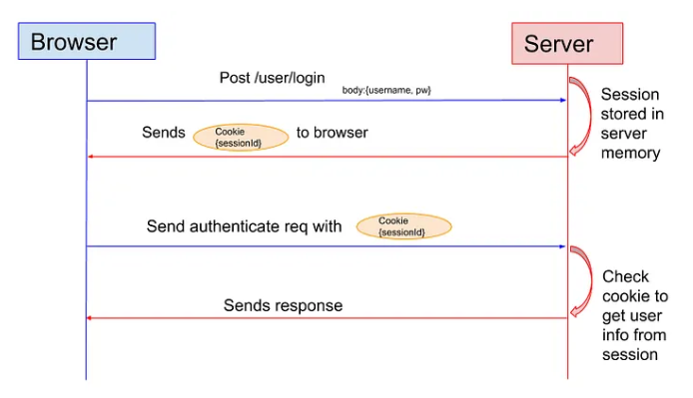
Session cookie characteristics
HTTP/1.1 200 OK
Content-Type: text/html
Set-Cookie: JSESSIONID=abc123xyz789; Path=/; HttpOnly; Secure; SameSite=Strict

- Secure -> Send only over HTTPS
- HttpOnly -> Client JS can’t read
- SameSite-> Prevent CSRF attack
- Should have some duration
- High Entropy IDs: Using cryptographically secure random strings

Challenge: If there are multiple servers each server will generate different sessionId. So request going to different servers not get authorized
Solution
- Sticky session
- memory (e.g. file system)
- cache (e.g. Redis or Memcached), or
- DB (e.g. Postgres, MongoDB)
each user is identified by a session ID example JSESSIONID
- opaque ref.
  - no 3rd party can extract data out
  - only issuer (server) can map back to data
- stored in a cookie
  - signed with a secret
  - protected with flags

Session fixation
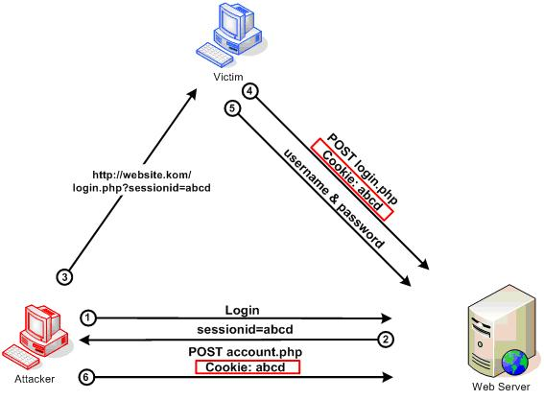
- The attacker visits a website and gets a valid Session ID (e.g., SESS123).
- The attacker sends a link to the victim containing that ID: [http://example.com/login?sessionid=SESS123](http://example.com/login?sessionid=SESS123).
- The victim clicks the link. it accepts SESS123 as the victim's current session identifier.
- The victim logs in with their username and password. The server, seeing they already have a session ID, keeps using SESS123 but upgrades its status to "Authenticated."
- The attacker, who already knew SESS123, now refreshes their browser and is automatically logged into the victim’s account.
Solution
- Generate a new session ID upon any privilege level change, especially after a user logs in.
- Do Not Accept Session IDs in URLs: Only accept session IDs via cookies
- Implement short, reasonable idle session timeouts.
- Set cookies to HttpOnly to prevent them from being accessed by scripts, and Secure to ensure they are sent over HTTPS.

Session Hijacking
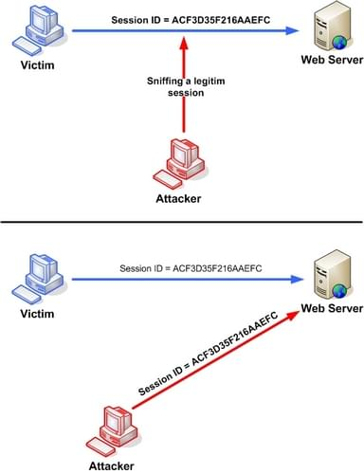
Taking over a user's active session
- Network Sniffing : If the site uses HTTP or has an insecure setup, the attacker uses tools on the same Wi-Fi network (like at a coffee shop) to intercept the data packets and read the Cookie header in plain text.
- Cross-Site Scripting (XSS): The attacker injects a malicious script into the website. When you visit the page, the script runs in your browser and sends your document. Cookie data to the attacker’s server.

Prevention
- SSL/TLS: Encrypts the header so it can't be read.
- HttpOnly Flag: Prevents scripts from reading the cookie.
- High Entropy IDs: Using cryptographically secure random strings.
- IP/User-Agent Binding: Checking if the user's "fingerprint" changed mid-session

CSRF
- You log into bank.com. Your browser receives a session cookie and stores it.
- While your bank session is still active in one tab, you visit a malicious website (or click a link in a phishing email) in another tab.
- The malicious site contains a hidden form or a script that triggers a POST request to bank.com/transfer.
- Your browser sees the request is for bank.com and attaches your session cookie to the request.
- The bank's server receives the request, sees your valid session cookie, and processes the transfer.
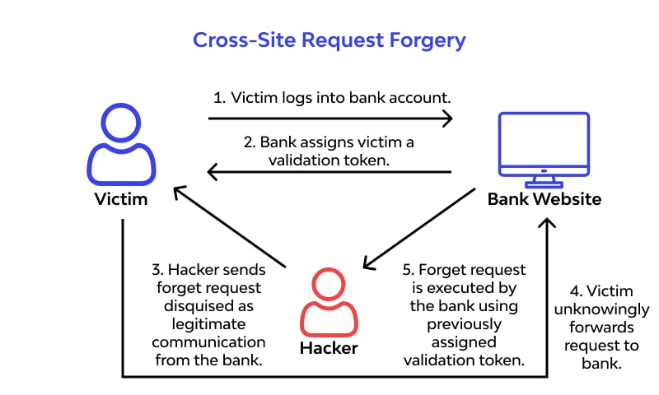
Solution
- Include a hidden field in the state change requests (CSRF only for POST/PUT) match it with server side. Malicious sites can’t read your domain request
- SameSite=Strict: The cookie is only sent if the request originates from the same site where the cookie was set.
- Check request origin and reject request from other domains

SSO
Single Sign-On (SSO) is an authentication scheme that allows a user to log in with a single ID to multiple systems

Single Sign-On (SSO) is an authentication scheme that allows a user to log in with a single ID and password to any of several related, yet independent, software systems.
Essentially, it moves the "trust" away from individual applications and centralizes it in one dedicated authority.

The Three Key Players
- The User/Client: The person trying to gain access.
- The Service Provider (SP): The application the user wants to
- The Identity Provider (IdP): The system that holds the user’s credentials and "vouches" for them (e.g., Okta, Microsoft Azure AD, or Google).

The Standard SSO Workflow (Step-by-Step)
When a user tries to access a Service Provider, the following handshake occurs:
- Access Request: The user navigates to the Service Provider (SP).
- Redirect to IdP: The SP sees the user isn't logged in. Instead of showing a login box, it redirects the browser to the Identity Provider (IdP) with an authentication request.
- Authentication: The user logs into the IdP (if they weren't already). This is where the actual password entry happens.
- Token Generation: Once authenticated, the IdP generates a digital "passport" (often called a Token or Assertion). This token contains the user’s identity information (email, name, etc.) and is digitally signed by the IdP.
- Token Delivery: The IdP redirects the user back to the SP, passing the token along (usually via a browser POST request or URL parameter).
- Validation: The SP receives the token. Because the SP "trusts" the IdP, it verifies the digital signature. If the signature is valid, the SP creates a local session for the user.
- Access Granted: The user is now logged into the SP without ever having typed their password into that specific app.

Common SSO Protocols
There are two main "languages" used to perform this handshake:

Protocol | Primarily Used For | Data Format
SAML 2.0 | Enterprise/Corporate Web Apps | XML
OIDC (OpenID Connect) | Modern Web/Mobile Apps & Social Login | JSON (JWT)

Federated SSO
Federated Single Sign-On (SSO) is an evolution of standard SSO that allows a user to access applications across different networks or organizations using a single set of credentials.
While standard SSO usually works within a single domain (like logging into different tools inside your company's private network), Federated SSO allows "Trust" to be shared between entirely separate entities.

The Concept: The "Trust" Agreement
In a federation, two organizations (the Identity Provider and the Service Provider) establish a formal trust relationship.
- Identity Provider (IdP): The organization that owns the user directory and authenticates the user (e.g., your company's Active Directory or Google).
- Service Provider (SP): The external application that wants to provide a service to that user (e.g., AWS, Slack, or Salesforce).
How the Process Works (Cross-Domain)
- The Request: You try to log into AWS (the SP) using your corporate email.
- The Redirect: AWS sees your email domain and knows it has a "Trust Agreement" with your company’s Okta/Azure AD (the IdP). It redirects you there.
- The Authentication: You log into your company portal as usual.
- The Assertion: Your company's IdP generates a digital assertion. A signed document saying, this is user A, and he dev restart EC2, create new instances in dev VPC, or user is in dev ops can have access to RDS, dashboards.
- The Handshake: Your browser carries this assertion back to AWS.
- The Entry: AWS verifies the digital signature from your IdP. Since it trusts your company, it lets you in without ever seeing your actual password.

Feature | Standard SSO | Federated SSO
Scope | Internal (Single Organization). | External (Multiple Organizations).
Trust Model | Local trust. | Shared, cross-domain trust.
Typical Protocol | Kerberos, Cookies. | SAML 2.0, OIDC.
Example | Logging into HR and Email on a company laptop. | Using your corporate credentials to log into AWS or Zoom.

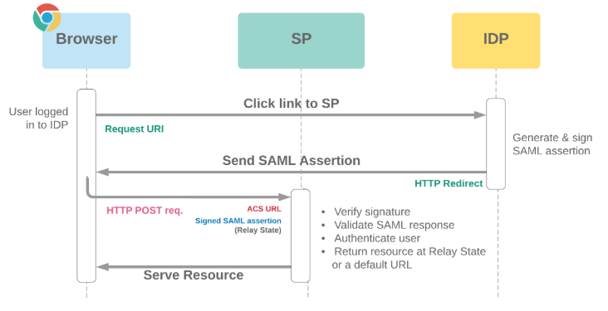

IAM
IAM = Identity and Access Management is a framework of policies and technologies used to ensure that the right people (or software services) have the appropriate access to technology resources.
IAM systems manage:
- Users
- Roles
- Permissions
- Authentication
- Authorization
- User lifecycle

5.2 User Lifecycle
Typical lifecycle:
- User creation
- Role assignment
- Permission updates
- Disable account
- Delete account

5.3 Relationship Between IAM and SSO
SSO is often part of IAM.
IAM manages:
- Identities
- Authentication policies
- Roles
- User provisioning
SSO provides:
- Seamless login experience

Module 6 — OAuth 2.0
6.1 What is OAuth?
OAuth is an authorization framework.
Important:
OAuth is mainly for authorization, not authentication.

6.2 Real-Life Example
"Login with Google"
You allow application to:
- Read profile
- Access email
Without sharing password with application.

6.3 Key OAuth Components
Resource Owner
The user.
Client
Application requesting access.
Authorization Server
Issues access tokens.
Resource Server
API containing protected resources.

6.4 Access Token
Short-lived token used to access APIs.

6.5 Refresh Token
Used to obtain new access tokens.
Important:
Usually longer lived.
Must be protected carefully.

6.6 OAuth Flows
Authorization Code Flow
Most secure web flow.
Client Credentials Flow
Machine-to-machine communication.
PKCE
Additional protection for public clients/mobile apps.

Module 7 — JWT (JSON Web Token)
7.1 What is JWT?
JWT is a compact token format.
Used for:
- Stateless authentication
- API security
- Identity propagation

7.2 JWT Structure
JWT has 3 parts:
header.payload.signature
Separated by dots.

7.3 Header
Contains:
- Algorithm
- Token type
Example:
{
"alg": "HS256",
"typ": "JWT"
}

7.4 Payload
Contains claims.
Examples:
- username
- roles
- expiration time
Important:
Payload is encoded, NOT encrypted.

7.5 Signature
Used to verify token integrity.
Prevents token tampering.

7.6 Stateless JWT Authentication Flow
- User logs in
- Server generates JWT
- Client stores token
- Client sends token in Authorization header
- Server validates token

7.7 JWT Storage Options
localStorage
Easy but vulnerable to XSS.
sessionStorage
Similar risk.
HttpOnly Cookies
Safer against XSS.

7.8 JWT Security Risks
XSS
Malicious JavaScript steals token.
Replay Attack
Attacker reuses stolen token.
Token Leakage
Sensitive data exposure.

Module 8 — SAML
8.1 What is SAML?
SAML = Security Assertion Markup Language.
XML-based authentication/authorization standard.
Used heavily in enterprise SSO.

8.2 SAML Components
Identity Provider (IdP)
Authenticates user.
Service Provider (SP)
Consumes SAML assertion.
Assertion
XML document containing identity information.

8.3 SAML Flow
- User accesses application
- App redirects to IdP
- User authenticates
- IdP sends SAML assertion
- SP validates assertion
- User gains access

8.4 SAML vs OAuth vs OIDC
Technology | Purpose
SAML | Enterprise SSO
OAuth2 | Authorization
OpenID Connect | Authentication layer over OAuth2

Module 9 — Mobile Authentication Security
9.1 Mobile SSO Challenges
Mobile devices increase risks:
- Device theft
- Malware
- Insecure apps
- Public WiFi

9.2 iOS Keychain
Secure storage system in iOS.
Used for:
- Passwords
- Tokens
- Certificates
Apps signed by same developer can securely share tokens.

9.3 Android Keystore
Secure storage mechanism in Android.
Used to securely store:
- Cryptographic keys
- Authentication secrets

Module 10 — Web Security Basics
10.1 XSS (Cross-Site Scripting)
Attacker injects malicious JavaScript.
Goal:
- Steal tokens
- Hijack sessions
- Modify UI

10.2 Types of XSS
Stored XSS
Malicious script stored in database.
Reflected XSS
Script reflected in request/response.
DOM XSS
Client-side JavaScript vulnerability.

10.3 Preventing XSS
- Output encoding
- Input validation
- CSP headers
- HttpOnly cookies
- Avoid unsafe HTML rendering

10.4 CSRF (Cross-Site Request Forgery)
Attacker tricks browser into sending unwanted request.
Common mitigation:
- CSRF tokens
- SameSite cookies

Module 11 — OpenID Connect (OIDC)
11.1 What is OIDC?
OIDC = OpenID Connect.
Authentication layer built on OAuth2.

11.2 Why OIDC Exists
OAuth tells:
"What app can access"
OIDC tells:
"Who the user is"

11.3 ID Token
OIDC introduces ID Token.
Usually JWT-based.
Contains user identity information.

Module 12 — Practical Backend Security
12.1 Secure Password Storage
Never store plain passwords.
Use hashing:
- BCrypt
- Argon2
- PBKDF2

12.2 HTTPS/TLS
Always use HTTPS.
Protects:
- Passwords
- Tokens
- Sessions
- API traffic

12.3 API Security Basics
Use:
- Authentication
- Authorization
- Rate limiting
- HTTPS
- Input validation

12.4 CORS Basics
Controls which origins can access APIs.
Very important in frontend-backend systems.

Module 13 — Spring Security Mapping
13.1 Spring Security Concepts
Concept | Spring Security
Authentication | AuthenticationManager
Principal | UserDetails
Authorization | GrantedAuthority
Session | SecurityContext
JWT Filter | OncePerRequestFilter

13.2 Important Spring Security Topics
- SecurityFilterChain
- AuthenticationManager
- UserDetailsService
- PasswordEncoder
- JWT filters
- Stateless authentication
- Role-based authorization
- CSRF
- Session management

Suggested Teaching Order
- Identity basics
- Authentication vs Authorization
- Sessions & Cookies
- SSO
- IAM
- OAuth2
- JWT
- SAML
- OIDC
- Web Security
- Mobile Security
- Spring Security mapping

Recommended Hands-On Exercises
Beginner
- Create login API
- Create session-based login
- Add role-based authorization
Intermediate
- Implement JWT login
- Add refresh token
- Add MFA simulation
Advanced
- Integrate OAuth login
- Integrate Google login
- Implement SSO flow
- Add secure cookie configuration

Common Interview Questions
Basic
- Difference between authentication and authorization?
- What is JWT?
- What is SSO?
- What is OAuth?
Intermediate
- JWT vs Session authentication?
- Why use refresh tokens?
- How does MFA help?
- What is federated identity?
Advanced
- Explain OAuth authorization code flow.
- Explain SAML authentication flow.
- Explain JWT security risks.
- How does Spring Security process authentication?

CIA Triad
It is the core model of information security used to design secure systems.
CIA stands for:
- C → Confidentiality
- I → Integrity
- A → Availability
Every security mechanism in software usually protects one or more of these three.
- Confidentiality → Only authorized people can see sensitive information.
- Integrity → Data cannot be changed incorrectly
- Availability → Data/service should be accessible when needed

Confidentiality
Preventing unauthorized access to information Only intended people/systems should read sensitive information. Like
- Passwords
- Bank details
- Aadhaar / SSN
- Credit card data
- API keys
- Medical records
- Company confidential documents
Technical examples
- Example 1 — Login password stored in plain text in DB If DB leaks it is huge breach. Correct: Store hashed password: $2a$10$...
- Example 2 — Client → Server (plain HTTP) -> Anyone on network can sniff traffic. Correct: Client → HTTPS → Server. Encrypted and Confidentiality maintained.
- Example 3 — Database encryption. Even if DB stolen → difficult to read.
How is confidentiality achieved?
Access control RBAC (Role-Based Access Control) e.g. Admin → full access, Employee → limited access, Customer → own data only
Encryption Data encrypted at rest for e.g. Database, Disk, Backups And in transit: HTTPS, TLS, SSH
Authentication Verify identity before granting access. Example using password, OTP, MFA , certificate auth
Data masking Example: Show: XXXX XXXX XXXX 1234 instead of full card number.
Least privilege Only minimum permissions.
Confidentiality attacks
- Phishing Scam: An employee receives a fake email tricking them into revealing login credentials, allowing hackers to steal proprietary corporate data.
- Man-in-the-Middle (MITM) Attack: An attacker intercepts communication on a public Wi-Fi network, stealing sensitive login credentials or documents sent over unencrypted channels.
- Unauthorized Database Access: A company leaves an Amazon S3 bucket unprotected, allowing malicious actors to download millions of customer files containing personal information.
- Insider Threat: A disgruntled employee with valid access steals confidential records and leaks them to a competitor.
- Hardware Theft: A laptop, phone, or external drive containing sensitive, non-encrypted files is stolen, allowing access to its contents.
- Packet Sniffing: Attackers use software to capture unencrypted data moving across a network. It directly violates confidentiality by exposing private traffic (like passwords or emails) to unauthorized eyes.
- Data Breach: This is the ultimate successful outcome of a confidentiality attack. Sensitive, protected data is copied, transmitted, viewed, or stolen by an unauthorized individual.
- Hardcoded Secrets: Developers leave API keys, passwords, or encryption keys directly inside source code.
- Logging Sensitive Data: Applications inadvertently write passwords, credit card numbers, or personally identifiable information (PII) into plain-text system logs.

Best practices
Always:
✔ Encrypt sensitive data
✔ Use HTTPS
✔ Proper authorization
✔ Secure secrets
✔ Mask sensitive data
✔ Avoid excessive logging
✔ Need-to-know access
Never:
✘ Hardcode secrets
✘ Store passwords plain text
✘ Send credentials over HTTP
✘ Give broad access

Integrity:
Data remains accurate, complete, and unmodified unless authorized No unauthorized modification. Example:
- Original: Transfer ₹1000, Attacker changes: Transfer ₹100000 Integrity broken.
- Signed cheque. If someone changes: 1000 → 100000 Integrity lost.
- Change: Role = USER to Role = ADMIN Privilege escalation.
- Software tampering: Malware modifies executable. Integrity compromised , e.g. verify which npm packages, which maven/Gradle jars are executing
How integrity is ensured
- Hashing Example: File hash: SHA256(file) Changed file → hash changes. Integrity check fails.(How JWT works)
- Digital signatures: Verify 1. sender authenticity 2. data unchanged
- Checksums : Detect accidental corruption (uses HASH)
- ACID transactions
  - Atomicity: All-or-nothing
  - Consistency: Keeps the database structure accurate, enforcing rules like constraints and triggers
  - Isolation: Concurrent transactions do not interfere with each other. Intermediate states of a transaction are invisible to others.
  - Durability: Guarantees that once a transaction is committed, it remains permanent, even during a system failure
- Input validation: Prevent invalid data.
- Authorization checks Only authorized updates allowed.
Integrity attacks
- SQL injection changing DB data
- malware modification
- MITM alteration
- unauthorized update
- config tampering

Best practices
✔ hashes
✔ signatures
✔ validation
✔ transactions
✔ authorization
✔ audit trail

Availability
Systems/data are accessible when needed. Example Bank server down: Customers cannot access money. Availability issue.
Technical examples
- Server crash: App unavailable.
- DB outage : Entire system down.
- Network failure: Service inaccessible.
- Disk full: App crashes.
- Certificate expiry: HTTPS stops.
- Availability attacks: DoS flood requests server overwhelmed.
- DDoS : Distributed attack. Massive scale.
- Ransomware: Locks systems. Unavailable.
- Resource exhaustion: CPU / Memory exhausted.
How availability is achieved
Redundancy :Multiple servers.
Load balancing: Traffic spread.
Failover: Backup instance takes over.
Backup & recovery: Restore service quickly.
Monitoring: Detect issues early.
Capacity planning: Enough resources.
Rate limiting: Prevent abuse.
Best practices
✔ HA architecture
✔ backup
✔ monitoring
✔ DR plan
✔ autoscaling
✔ WAF
✔ DDoS protection

Tradeoffs
Sometimes CIA conflicts.
- Strict auth increases confidentiality but reduces usability.
- Encryption improves confidentiality but may affect performance.
Need balance.
Strong security is costly, but lack of it is even more costly

Terminologies in Security

Vulnerability
A weakness or flaw in software/system that can be exploited
Software examples
- Example 1 — SQL Injection
Code:
String sql = "SELECT * FROM users WHERE name='"+name+"'";
Weakness present.
- Example 2 — Hardcoded password
- Example 3 — Open S3 bucket Sensitive files public.
- Example 4 — Old library Using outdated dependency with CVE.
Types of vulnerabilities
Design vulnerability: Bad architecture. Example: Weak authorization layer.
Implementation vulnerability Coding bug. Example: Buffer overflow.
Configuration vulnerability Wrong config. Example: Debug mode enabled in production.
Operational vulnerability Poor maintenance. Example: No patching.

Threat
Anything capable of exploiting a vulnerability Simple: Potential danger.
Threat examples
- hacker
- malware
- insider employee
- competitor
- ransomware gang
- natural disaster
- accidental deletion
- bot traffic Bots / scanners.

Exploit
Method/code/technique used to attack vulnerability
Vulnerable code:
query = "SELECT * FROM users WHERE name='"+input+"'";
Exploit input:
' OR '1'='1
This payload = exploit
Examples
- malicious payload
- crafted URL
- exploit script
- malware
- privilege escalation code
- RCE exploit Remote Code Execution

Risk
Possibility that threat exploits vulnerability causing impact
Risk = Likelihood x Impact

Example
- Weak password policy.
  - Threat: Brute force attacker.
  - Likelihood: High.
  - Impact: High.
  - Risk: Very High.
- Minor internal tool exposure.
- Debug logs exposed.

Attack Surface
All possible entry points attacker can attack
Examples
- login page
- APIs
- admin portal
- upload endpoint
- DB port
- SSH port
- exposed buckets
- dependencies
- mobile app
- browser Java script
Large attack surface = bad More entry points. More risk.
Reduce attack surface
Disable:
- unused APIs
- debug endpoints
- open ports
- unnecessary services
- Apply least privilege.
E.g. Apple has historically resisted and challenged US government requests that require compromising user privacy, most notably by refusing to create "backdoors" to encrypted iPhones. The most prominent instance was in 2016 when Apple opposed a court order under the All-Writs Act to create specialized software to bypass security measures on an iPhone used in the San Bernardino terrorist attack

Security Control
Protection implemented to reduce risk. Examples:
- firewall
- MFA
- validation
- encryption

Detects attack. Examples:
- IDS: (Intrusion Detection System): Focuses on detecting and reporting malicious activity on networks or host systems.
- SIEM: (Security Information and Event Management): Collects data from IDS, firewalls, and servers to provide a holistic, centralized view of security.
- monitoring
- logs
Fixes after attack. Examples:
- restore backup
- patch vulnerability
Relationship of all terms
query = "SELECT * FROM users WHERE name='"+input+"'";
If an attacker enters ' OR '1'='1 as the input, the query becomes:
SELECT * FROM users WHERE name='' OR '1'='1';
Since '1'='1' is always true, the database returns all user in the table,
Weak code → Vulnerability
Attacker → Threat
Payload:
' OR 1=1 --
→ Exploit
Data stolen → Impact
Chance + impact → Risk
Prepared statement → Security Control
String sql = "SELECT * FROM users WHERE name = ?";
PreparedStatement pstmt = connection.prepareStatement(sql);
pstmt.setString(1, input);
ResultSet rs = pstmt.executeQuery();
If the user inputs ' OR '1'='1, the database will look for a user whose literal name is the string "' OR '1'='1"

Secure SDLC
Secure Software Development Life Cycle
Traditional SDLC: Requirement → Design → Development → Testing → Deployment → Maintenance
Secure SDLC: Requirement → Security Design → Secure Coding → Security Testing → Secure Deployment → Continuous Monitoring
Meaning: Security is built in from day one, not added later
Fix cost grows later. Early fix = cheap | Late fix = expensive

Late fix may require:
- code rewrite
- migration
- downtime
- audits
- penalties
Core Secure SDLC Principles
- Security by Design: Security should be part of architecture and design from beginning
    - Authentication: Which option to use JWT / Session /OAuth
    - Data protection: encryption / masking /retention
    - Availability: HA / backup /failover

- Shift Left Security
Bad:
Code → deploy → pentest → panic
Good:
Design review -> Secure coding -> Code scan (SonarQube, Checkmarx, Fortify) -> Dependency scan (Snyk, OWASP Dependency Check-> Security test ->Deploy

- Threat Modeling: Thinking like attacker before building. How can this system be attacked?
STRIDE Microsoft model:
- S → Spoofing Pretending to be someone else. Example: stolen JWT
- T → Tampering Modify data. Example: change amount.
- R → Repudiation User denies action. Need logs.
- I → Information disclosure Sensitive data leak.
- D → Denial of Service, e.g. service unavailable.
- E → Elevation of Privilege USER becomes ADMIN.
- Secure coding
- Validate and Sanitize Input: Assume all user input is malicious. Use allow-lists to validate types, lengths, and formats before processing data to prevent injection attacks (SQLi, XSS).
- Implement Proper Authentication & Access Control: Use strong, salted hashing for passwords (e.g., Argon2, bcrypt) and enforce least privilege, ensuring users only access necessary data.
- Use Secure Cryptographic Practices: Encrypt sensitive data both at rest and in transit (using TLS 1.3). Never hardcode keys or use deprecated algorithms like MD5.
- Secure Logging and Error Handling: Log security-critical events (login failures, input validation errors) without storing sensitive information like passwords or PII.
- Manage Dependencies Safely: Frequently scan third-party libraries and open-source components for known vulnerabilities.
- Adopt Security by Design: Integrate security early in the Software Development Life Cycle (SDLC) through threat modeling and regular security training.
- Use Automated Testing: Incorporate Static Application Security Testing (SAST) during development and Dynamic Application Security Testing (DAST) in staging to identify flaws
- Secure Testing
- SAST (Static Application Security Testing): Analyses source code, byte code, or binaries without running the application
- DAST (Dynamic Application Security Testing): Simulates external attacks on a running application, testing from the outside in
- IAST (Interactive Application Security Testing): Combines SAST and DAST by placing agents inside the application server to monitor execution. It provides the code-level visibility of SAST with the runtime context of DAST
- Penetration testing: authorized simulated attack on an entire system or network to evaluate its overall security posture
- Fuzz testing: Fuzz testing is an automated technique that feeds massive amounts of random, malformed,
- Unit security tests: Unit security tests focus on the smallest testable parts of an application—individual functions or methods—to ensure they handle security-sensitive logic correctly. Example: Test invalid JWT. Test privilege escalation. Test SQL payload.
- Third-Party Risk Management: Scanning and managing vulnerabilities in open-source components and third-party libraries.
- Developer Training & Culture: Educating developers on security best practices and fostering shared responsibility for security.

Shared Responsibility Model
Security ownership is distributed across teams
- Developers :
- Architects:
- DevOps / Platform team
- Security / AppSec team
- Operations / SRE
- Database administrators
- Cloud provider
- Management / Leadership
- End users

